***How to create a .exe installer***

1. Download the software “Inno Setup Compiler”
2. Click on File->New then Next
3. Fill in the information asked, like that:

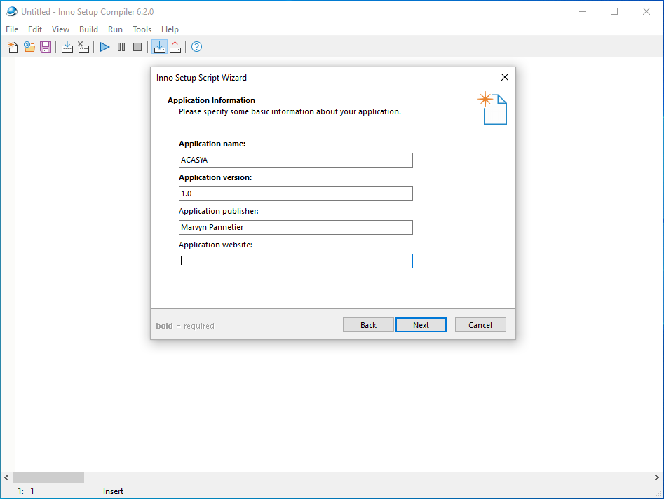

1. Then click on Next until this window:

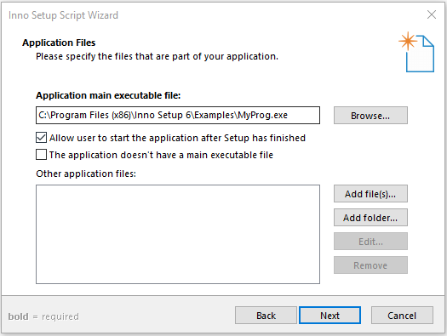

1. Click on *Browse* and select your ACASYA.exe generate by LabWindowsCVI. Then click on *Add Folder* and select the folder called “Necessary files for installation” say YES to the popup about the subfolders and click on Next
2. Click on Next until the window below and choose the second option like on the screenshot:

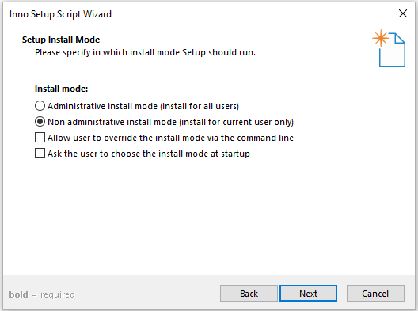

1. Next until this window that you must fill in like that for example:

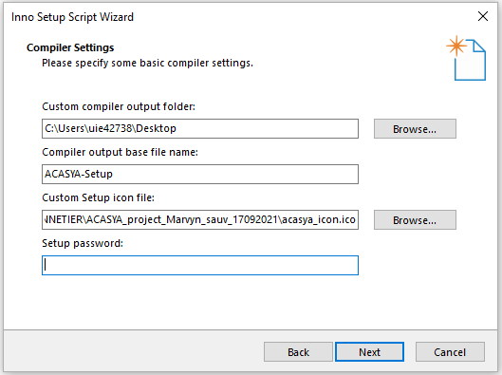

1. Next two times then click on Finish, two popups will appear, say Yes to the both, save it and your installer will be created at the place you chose before!